Chapter 5: The Standard Deviation as a Ruler

and the Normal Model

1. **Standardizing with z-Score:**
2. Open the data file (2008 Olympic Games.csv).

**Note:** there are some missing values in the variable long jump.

1. Prepare a table by typing the following

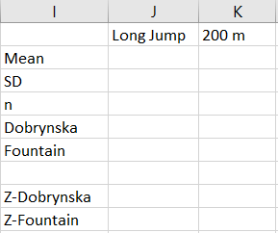

1. Similar to what we have done in Chapter 3 – Part 2, Select the **Formulas** tab $⟹$**More Function $⟹$ Statistical $⟹$** Formula.

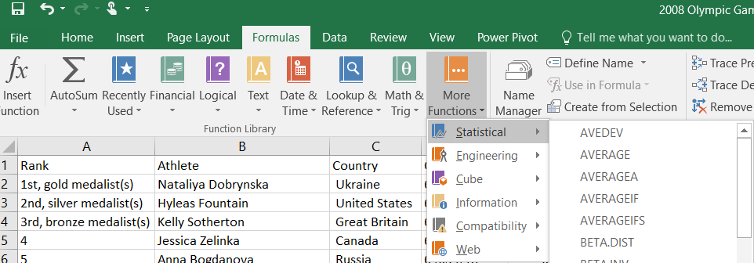

1. Additional to the functions **AVERAGE** and **STDEV.S**, we will use 2 new functions which are **COUNT** and **STANDARDIZED**. We will use the function **COUNT** to count the number of observations in the sample (sample size).





**Note:** in the **STANDARDIZED** function, x is the value (cell) to normalize, mean is the average of the sample, and standard_dev is the standard deviation of the sample.

|  |  |  |
| --- | --- | --- |
|  | Long Jump | 200 m |
| Mean |  |  |
| Standard Deviation |  |  |
| n  number of observations) |  |  |
| Dobrynska | 6.63 | 24.39 |
| Fountain | 6.38 | 23.21 |
|  |  |  |
| Z – Dobrynska |  |  |
| Z - Dobrynska |  |  |

1. The result is

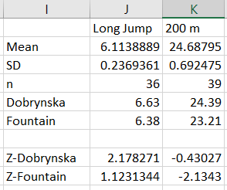

1. **Finding Normal Percentiles:**
2. Open the data file (SAT_Scores.csv). In this file, there are 2 variables which are Math and Verbal.
3. Similar to what we have done in Chapter 3 – Part 2, Select the **Formulas** tab $⟹$**More Function $⟹$ Statistical $⟹$** Formula



1. Additional to the **AVERAGE,** **STDEV.S**, and **STANDARDIZED** function. We will use the function **NORM.S.DIST** which returns the standard normal percentile.



where **z** is the Z score. If “cumulative” = TRUE, the area under the curve to the left of “X” is returned. If “cumulative” = False, the height of the curve at “X” is returned.

**Note:** We may use the **NORM.DIST** function instead of **NORM.S.DIST** function



where X is the value for which we wish to calculated the distribution, mean is the average of the sample, and standard_dev is the standard deviation of the sample, and cumulative is same as in **NORM.S.DIST** function.

|  |  |  |  |
| --- | --- | --- | --- |
| Mean |  | Z_450 |  |
| Standard Deviation |  | Z_600 |  |
|  |  |  |  |
| Score 1 | 450 | P( Z < 450) |  |
| Score 2 | 600 | P(Z < 600) |  |
|  |  | P(450 < Z < 600) |  |

1. The result is

